Lecture 7

chapter 25 Electric potential



“When a charge q is placed in an electric field E created by some source charge distribution, the particle in a field model tells us that there is an electric force q E acting on the charge. This force is conservative because the force between charges described by Coulomb’s law is conservative.” (Serway…)

Why “the force between charges described by Coulomb’s law is conservative” ?

work done by force is: $W=\vec{F} ∙\vec{s}$

F is an exerted force and s is a displacement

“a conservative force is a force which performs no work on a closed loop: $\oint{\vec{F}d\vec{s}=0}$ Take two paths from point A to point B. Because the work around the entire loop is zero, we know that the work along one path from A to B equals minus the work along the other path from B to A. Switching the limits of integration, the work along both paths from A to B is equal. That is, conservative forces are path-independent.”

$$\int_{A}^{B}{F∙ds} \left(path1\right)= \int_{A}^{B}{F∙ds} (path2)$$

From Newton’s 2nd law: $Work = F s = ∆K$, K – kinetic energy

if F is not constant, $W= \int_{A}^{B}{\vec{F}} ∙d\vec{s}= ∆K$

We can introduce potential energy U for conservative force:

$$∆U= U\left(B\right)-U\left(A\right)=-\int_{A}^{B}{\vec{F}} ∙d\vec{s}= -W$$

Then $∆K= -∆U$

$∆K+∆U=0$

K + U = constant (energy conservation)

“The electrostatic force is conservative not because of the inverse square law, but because the force is radially symmetric. Draw a closed loop consisting of four segments: r = r1, θ = θ1, r = r2, and θ = θ2. The work is zero along the arcs θ = θ1 and θ = θ2, and the work is equal but opposite along the radial legs r = r1 and r = r2. Then it’s easy to see that the total work is zero.”

Since the electrostatic force is conservative, we can introduce potential energy U for our test charge q in the external electric field. And change of the energy of the charge when it moves from A to B is:



It is equal to “minus” work done by the electric force

U is a potential energy of a charge.

Electric potential V is defined as:

$$V=\frac{U}{q}$$

The **potential difference** ΔV = *V*B - *V*A between two points A and B in an electric field is defined as the change in electric potential energy of the system when a charge *q* is moved between the points (Eq. 25.1) divided by the charge:



The potential *difference* between A and B exists solely because of a source charge and depends on the source charge distribution

For potential energy we need include a charge (multiply the potential difference by the charge q)

If an external agent moves the charge q from A to B, it performs work on the charge that is equal to the change of potential energy of the charge:



Unit of electric potential:

1V = J/C

from 25.3 : Electric field is V/distance :

N/C = V/m



electron-volt: e*1V

energy electron gains as it is moved through a potential difference of 1 V



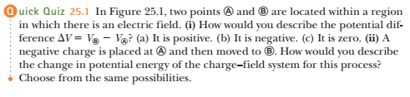

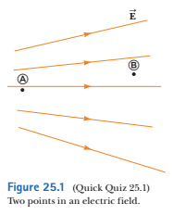





This is a general case for arbitrary electrostatic field

Let’s consider a uniform electric field E

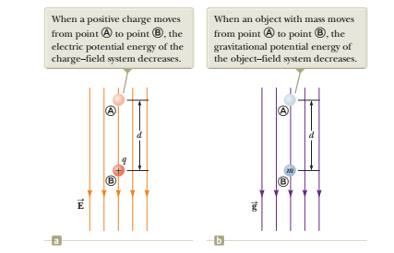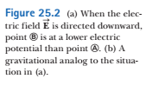

potential difference between A and B is:



since E is constant:

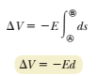

so, VB is less than VA

Electric field lines always point in the direction of decreasing electric potential as shown in Figure 25.2a

Now suppose a charge *q* moves from A to B.



So, for a positive charge, potential energy decreases as q moves in the direction of the field

q accelerates and gains kinetic energy

compare with the gravitational field (Figure 25.2 b above)

the difference : q can be negative

a free negative charge moves against the direction of the electric field

…

Consider an electric charge that moves from A to B with **s** not parallel to **E**

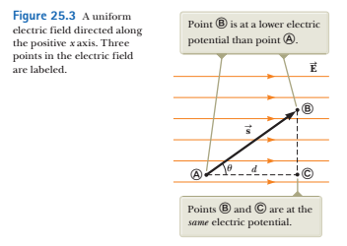





all points in a plane perpendicular to a uniform electric field are at the same electric potential

Equipotential surfaces for a uniform field are planes perpendicular to the electric field

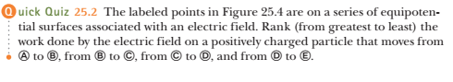

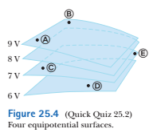



A battery has a specified potential difference D*V* between its terminals and establishes that potential difference between  
conductors attached to the terminals. A 12-V battery is connected between two parallel plates as shown in Figure 25.5.  
The separation between the plates is *d* 5 0.30 cm, and we assume the electric field between the plates to be uniform.  
(This assumption is reasonable if the plate separation is small relative to the plate dimensions and we do not consider  
locations near the plate edges.) Find the magnitude of the electric field between the plates.

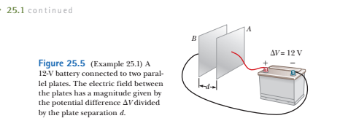



so,



this configuration is called a “parallel plate capacitor”



A proton is released from rest at point A in a uniform electric field that has a magnitude of 8.0 x 104 V/m (Fig. 25.6). The proton undergoes a displacement of magnitude *d* = 0.50 m to point B in the direction of **E** . Find the speed of the proton after completing the displacement.

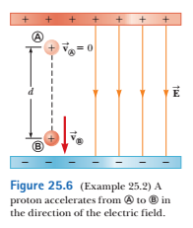

this is similar to an object falling through a gravitational field

Hence, energy of the proton is conserved:



